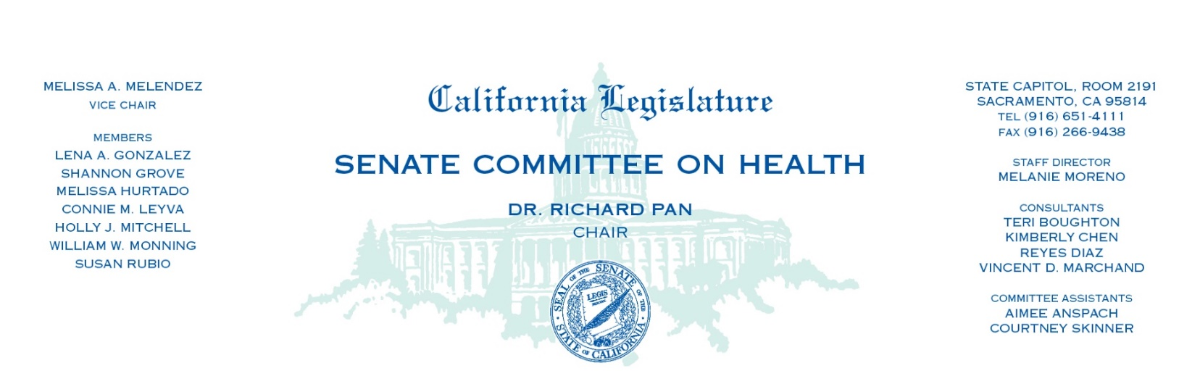

AGENDA
The Affordable Care Act in Jeopardy: What does it mean for California?
Wednesday, October 21, 2020—1:30 p.m.
State Capitol, Senate Chambers

Opening Remarks

- Dr. Richard Pan, Chair
Affordable Care Act Overview and Legal Status

- Deborah Reidy Kelch, MPPA, Independent Consultant
- Melanie Fontes Rainer, Special Assistant to the Attorney General, Department of Justice

California Impacts

- Peter Lee, Executive Director, Covered California
- Will Lightbourne, Director, Department of Health Care Services and Jacey Cooper, State Medicaid Director and Chief Deputy Director of Health Care Programs
- Ben Johnson, Principal Fiscal and Policy Analyst, Legislative Analyst Office

California Consumers

- Namir Yedid (San Diego)
- Angela Eilers (Orange County)
- Charis Hill (Sacramento)

Health Care Providers

- Jennifer Cruikshank, CEO, Riverside University Health System-Medical Center & Clinics
- Leslie Abasta-Cummings, CEO, Livingston Health Center, Merced County
- Beth Griffiths, MD, MPH, Assistant Clinical Professor in the Division of Internal Medicine at the University of California, San Francisco

Consumer and Business Advocates

- George Balteria, CEO, Collective:Choice Insurance Solutions
- Jen Flory, Policy Advocate, Western Center on Law and Poverty
- Jeffrey Reynoso, Executive Director, Latino Coalition for Healthy California
- Preston Young, Policy Advocate, California Chamber of Commerce
- Anthony Wright, Executive Director, Health Access California

Public Comment

